Unit 6: Weather- Understanding Weather Variables
Name:__________________________________ Date:______________________ Block:___________
Weather:

_____________________________-are individual pieces of information that describe specific conditions of the atmosphere.
Examples:
Forecasting – is making ______________ based upon _________________conditions of the atmosphere.
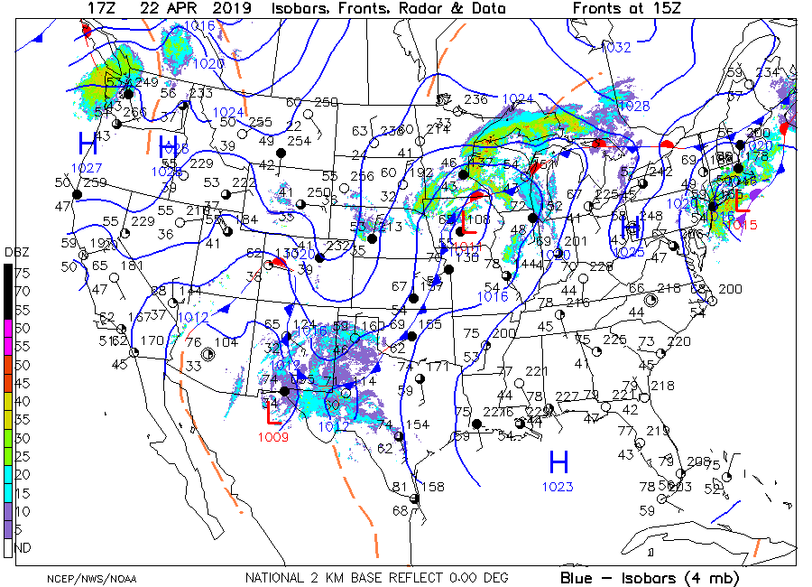
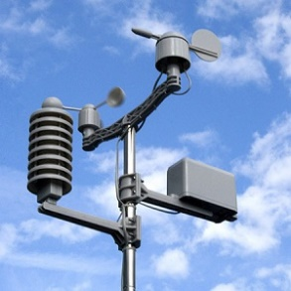
Weather Stations: ________________
____________________________________
____________________________- provide a picture of the weather conditions at a given time

- Temperature:

- measured in °C/F (less commonly, Kelvin or K)
Room Temperature according to pg. 13 of the ESRT: ____________°F or ______________°C
- Barometric Pressure:

- Measured in _________________ (mb), ___________________ of mercury (“), and atmospheres (atm).
- Air pressure depends on how _________________ packed the molecules are and how _____________ they are.
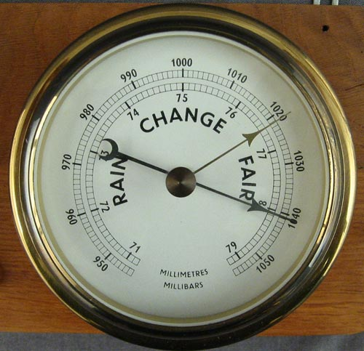
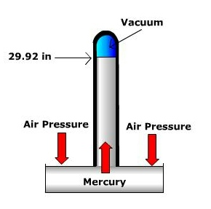
- Sea Level Pressure or “One atmosphere” is equal to _______________mb OR_________________” of mercury ( on pg. 13 ESRT)
- Barometer:
- At sea level there is ______________ lbs. of pressure/inch
Relationships:
- ________________________: Why? Air _____________ when _______________(Density ↓)
- _________________________: Why? Air __________________ when __________ (Density ↑)
A change in ___________________ causes the _________________and __________________ of air. The exchange of air from regions of _________________ to ______________ pressure= ________________!
- Wind Speed and Direction
  - Wind is the ______________________ ____________________________of air.
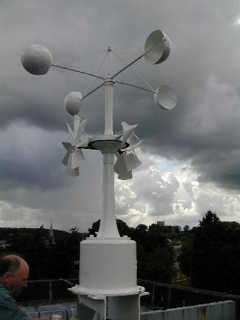
  - Wind occurs because of _______________ _________________________on earth.
  - The ________________the difference in_____________________, the _________________the wind speed. Speed is given in mph or in knots.
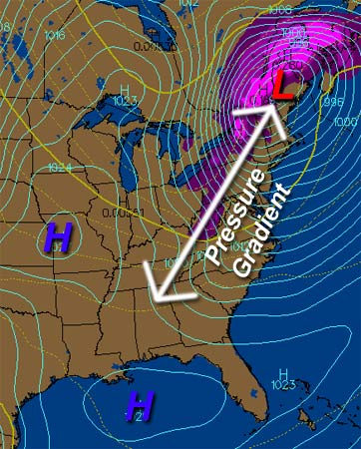
  - Wind is named for the direction ______________________________ it comes (a “SW” wind blows NE)
  - An __________________________________ measures wind speed/direction
  - Air flows from regions of ___________________ to ______________ Pressure
  - And is ______________ where the ________________________________ is the _____________________________ ( ∆Pressure (high-low)/Distance)
Draw and label diagrams of a sea breeze and a land breeze including information on relative temperatures (cool vs. warm), pressures (high vs. low), and the direction the air moves vertically (rising or sinking) and the direction the air moves horizontally between the zones of land and sea (wind).
Sea Breeze (Day) | Land Breeze (Night)

- Dew Point Temperature: temperature at which water vapor will _______________________________to become drops of water or ice crystals.
  - It indicates how ______________________the air is
  - The air must be ________________ for this to happen
  - The dewpoint temperature depends on the amount of ____________________________ in the air;
It DOES NOT depend on the _______________________________
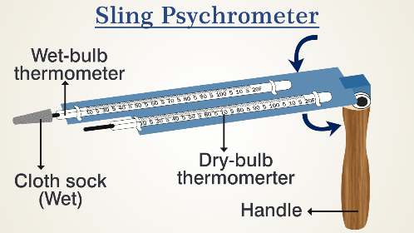
  - A _____________ dewpoint temperature indicates a ____________ concentration of water vapor.
How to Measure Dew Point Temperature:
- Using a _____________________________________
Dry Bulb | Wet Bulb | Dry-wet | DPT
26°C | 20 °C
6 °C | 5 °C
12 °C | 8 °C
18 °C | 17 °C
14 °C | 14 °C
0 °C | -3 °C
- This will yield two temperatures: A “_________________________” temperature and “__________________________” temperature
- In order to find the dew point, you must find the __________________ between the dry and wet bulb temperatures (____________________) and your ESRT page _______________ (Dew Point Chart)
Dry Day:
- _____________________of moisture will evaporate.
- The wet bulb will be ____________________than the dry bulb.
Humid/Wet Day:
- A __________________of moisture will evaporate.
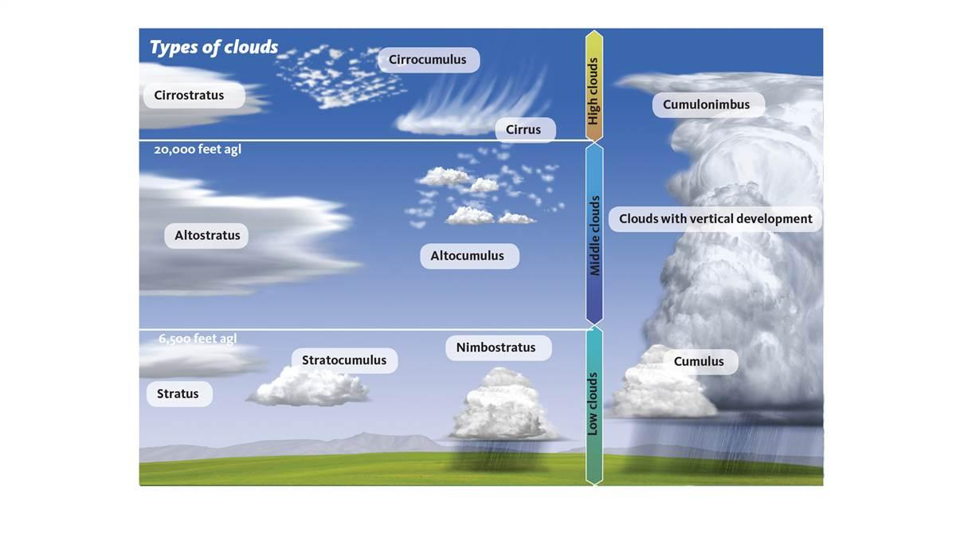
- The wet bulb will ______________ be much cooler than the dry bulb.
Dew Point and Cloud Formation:
________________________temperature and ___________________ temperature determine the _________________ at which water vapor will condense to form ___________________ in the sky, ___________________ or ___________ on the ground… On a dry day, the air must cool ___________________ in order to form a cloud (lower DP temp), thus the air must rise ________________________ into the troposphere for condensation to occur.
- Absolute Humidity: refers to ___________________________________________________________________
Fact: Water vapor molecules are ___________________than Nitrogen molecules. This means that ______________ air is ___________________ than dry air
As a result:
- As_______________________________________ (H20 molecules replace N molecules)
If air pressure decreases, air can _________________, thus holding more _________________
Making the connection: Why does the air feel more humid during the summer months?
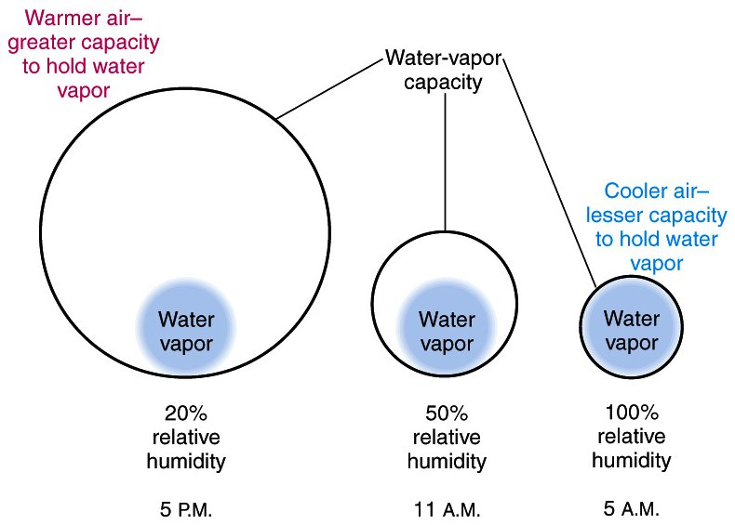
- Relative Humidity
-It compares the amount of ___________________in the air (%), to the amount the air can __________ which is based upon the __________________________________.
-As air temp ______________, Relative humidity will __________
-A 100% RH means the air is ________________________.
-At ground level this will indicate ___________________.
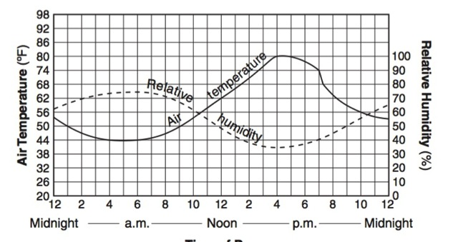
Making the connection: Why is it always more humid, wet, or “dewy” during the morning hours of the day as compared to the afternoon?

Relationship of Relative Humidity to Air Temperature:

Relative Humidity Problems using pg. 12 of ESRT
1.)What is the RH if the dry bulb temperature is
10 ˚ C and the wet bulb is 8˚C? ________
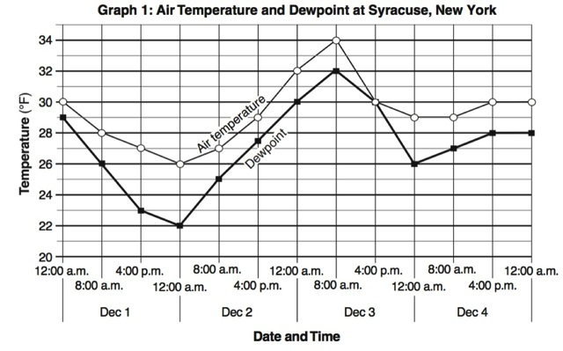
2.)If the difference between the dry and wet bulb is 6 C˚, and the relative humidity is 41%, what is the Dry bulb temperature ?_________
3.) What is the relative humidity if the dry bulb temperature is 18 C and the Dewpoint is 18 C? ________
what is likely to form at ground level?
Using the graph, at what time of day would you predict precipitation to occur in Syracuse using information on air temperature and dew point? _________________________
In Summary:
HEAVY AIR (High Pressure) | Light Air (Low Pressure)

